## Week 1 – Attention Models

1. What are the direct inputs to compute the attention weight $α_{ij}$?

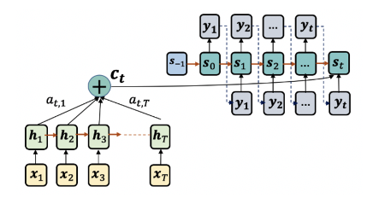

$h_{j},s_{i-1}$

1. How do you compute the dynamic context vector $c_{i}$?
$\sum_{j}{α_{ij}h_{j}}$

2. What are the direct inputs to decoder $s_{i}$?
$s_{i-1},y_{i-1},c_{i}$

3. Which steps compute the attention weights in the RETAIN method?

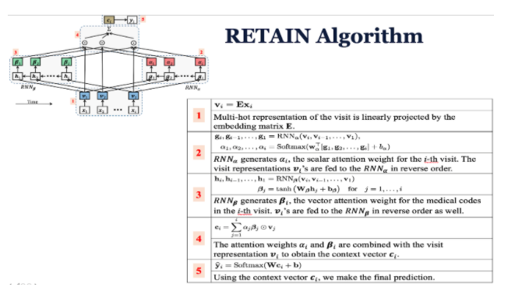

* 1. Step 2; Step 3

1. What is the clinical application of RETAIN method in their paper?
   1. Heart failure prediction
2. In the GRAM method, which step computes the context vector in the attention mechanism?

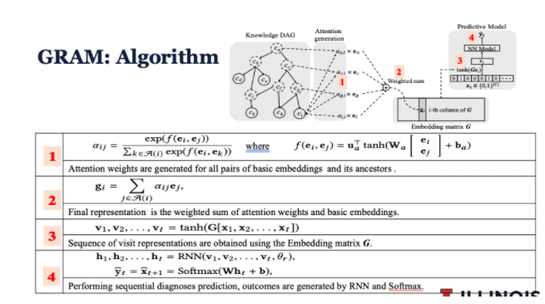

* 1. Step 2

1. Why do you think GRAM generates nice embedding clusters for diagnosis codes?
   1. Because it leverages the knowledge hierarchy of diagnosis codes.
2. In the CAML method, what other neural network architecture is used besides the attention mechanism?
   1. CNN
3. What is the clinical application of CAML?
   1. Medical image classification
   2. Patient triaging model
   3. Mortality prediction
   4. Diagnosis coding from clinical notes
4. What is the input data to MINA method?
   1. Electrocardiogram (ECG)

## Week 2 – Graph Neural Networks

1. What are applications of graph neural networks?
   1. Node classification
   2. Link prediction
   3. Graph property prediction
   4. Community detection
2. What are the challenges of using neural networks on graphs?
   1. Arbitrary size
   2. No fixed node ordering
   3. Dynamic updates
   4. Heterogeneous features
3. What is not part of the input to graph neural networks?
   1. Importance weights of nodes
4. Which one is NOT a computational step in graph neural networks?
   1. Iteratively update the underlying graph structure
5. What is the aggregation function of the following GCN update?
 $$h_{i}^{l+1}=σ(h_{i}^{\left(l\right)}W^{l}+\sum_{j∈N_{i}}{h_{j}^{\left(l\right)}}W^{l})$$

  1. Summation
6. What is NOT true about GCN model?
   1. The number of parameters in GCN is proportional to the graph size.
7. In MPNN, what is the message passing update for node CC?
$Mt(h_{C},h_{A},e_{CA})+Mt(h_{C},h_{B},e_{CB})+Mt(h_{C},h_{E},e_{CE})$

8. What is NOT true about read-out operation in MPNN?
   1. The read-out operation is the most expensive step in training MPNN.
9. What is NOT true about the GAT model?
   1. Attention weights are on all pairs of nodes in the graph
10. What are the different node types used in polypharmacy network?
    1. Drug molecules
    2. Protein targets